**Project 1 - Data Scientist Job Market (US)**

The Top 3 Job positions that are looked for are Data Scientist, Research analyst and research scientist. We discarded engineer, because it is too unspecific.

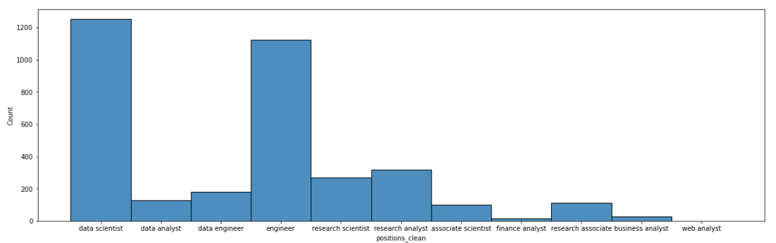

The top 3 states, meaning states with the most open job positions are California, MA and WA and NY.

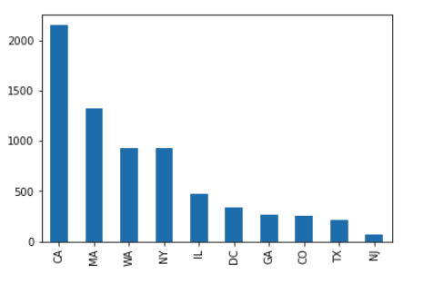

Most of the positions advertized do not indicate specific seniority level. It can be assumed, therefore, that these are mid-level positions. The 2nd most required seniority level is senior. There is very little need for junior level positions.

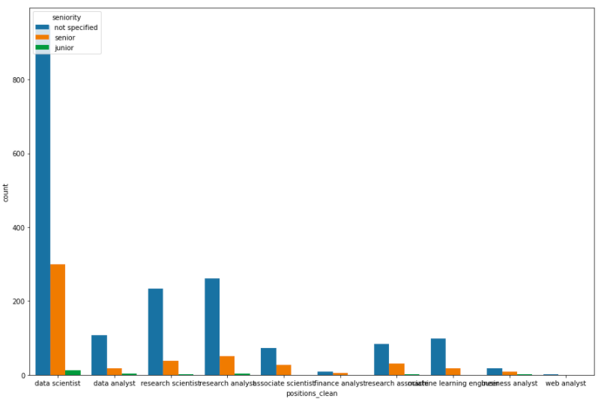

Nearly all job openings required a degree of some sort. The majority only required a degree, but nearly half specified a masters as a requirement. A much smaller but substantial minority requested PHD level education as required or desirable.

